M. Buddhima Isanka
Curriculam Vitae

Contact détails

Phone:
Mobile: +94 718345927
Home: +94 112976785

E-mail Address:
isanka.maldeniya@gmail.com

Mailing addresses:
Residence: No: 292/1, Dickwela Road,
Siyambalape,
Sri Lanka.

Profile in brief :

BSc.Finance Management (Special) at the University of Sri Jayewardenepura.

Successfully completed the Operational Level examination of the Chartered Institute of Management Accountants and currently following Management Level.

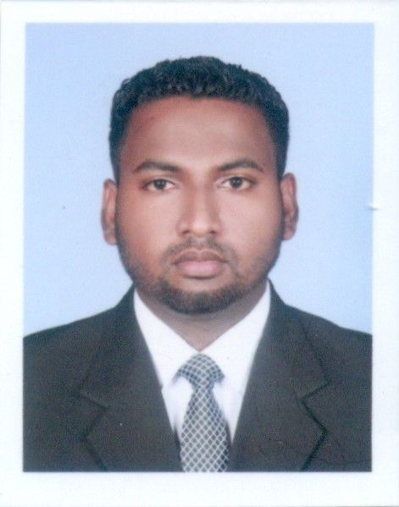
Objective | - To obtain a challenging position in a leading business organization where my knowledge, experience, skills and personal values will be suited and utilized to achieve standards of excellence and to be a dynamic leader to drive the business towards the vision and mission of the organization.
Personal Information | Name in full : Maldeniyage Buddhima Isanka  Mailing address : 292/1, Dickwela Road, Siyambalape.  Permanent address : 292/1, Dickwela Road, Siyambalape.  Date of birth : March 03, 1989  Sex / Civil status : Male / Single  NIC No : 890631908 V  Nationality : Sri Lankan  School attended : Bandaranayaka College Gampaha, Sri Lanka
Academic qualification | - Bachelor of Science degree in Finance Management from the University of Sri Jayewardenepura in 2015.  - Passed GEC (A/L) with three (3) “A” passes in 2009.  - Passed GEC (O/L) with seven (7) “A” and two (2) ”B” passes in 2005.
Professional qualifications | - Successfully completed the Operational Level and Following Management Level Examination of the Chartered Institute of Management Accountants (CIMA)
Other qualification | - 2005 Certificate in Australian National Chemistry Quiz Conducted by Royal Australian Chemical Institute
Computer and IT skills | - Ability work with Office software package (MS word, MS Power point, MS Excel)
Extra curricular activities | - Held the position of vice presidents in University (Student Association of Finance)  - Involved different roles which lead to the development of leadership qualities, team work, negotiation and persuasion skills.
Non–related referees | - Mr. I.A. Asiri Chamara  (Accountant)  East West Marketing (Pvt) Ltd  297/2,  George R De Silwa Mawatha,  Colombo 13.  Contact details: 0117441111/0772957842  - Ms Chamanthi Perera  (Accountant)  Pantak Power (Pvt) Ltd  2A,  Sulaiman Terrece,  Jawatta Road,  Colombo 05.  Contact details: 0112507324/0772957841

I do hereby certify that the above information is true and correct to the best of my knowledge,
…………09.03.2016.………… ……………………………
Date Signature

